Overall FYP
Details of the project : I want to develop a super capacitor based sensor node for a agriculture field, to send data at least 3 times per day. Its a battery less system. VolfPack (https://www.volfpackenergy.com/) is the guy who collaborate with us to give the supercapacitors. Basically they are the client in industry terms.

Objectives :
Design a solar-powered, battery-free agricultural sensor node and is based on the use of supercapacitors as the energy storage medium and can be deployed on an industrial scale.

Decompose regional solar energy trends and deploy smart charging and power-management strategies that optimize the supercapacitor life and useful energy in changing environmental conditions.

Design and develop a power-management interface that:
Efficiently harvests solar energy, safely charges and balances supercapacitors
Provides regulated power to an MCU sensors and a wireless radio for 2–3 daily sensing/transmission cycles

Demonstrate the system with laboratory and field tests of the solar irradiance, temperature, humidity, energy harvested, energy delivered per cycle, uptime, and reliability and show a low-cost one-no-maintenance solution suitable for the long-term monitoring of agriculture.

User given limitations (by volfpack) : 5F each - can use multiple if needed
2.7V

I have found two useful reference papers related to this project (Attached pdf's). If you found better solutions than this, bring them to the table if possible. But these are having backup with battery, to claim novelty we may do something really advance. (Completely battery less)

I am planning to do a black box now and I have ordered the components also!
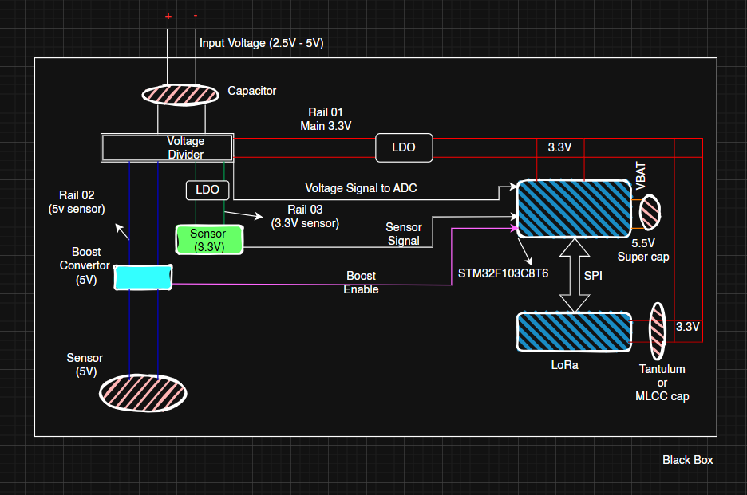
Since I have this black box, if it worked as expected then, I can analyze the power.
If I get some Idea, I can finalize the super capacitor bank, which I need to use, and if I want I can work on the MPTT, auto path management system, to supply the input voltage.
Sensor Node
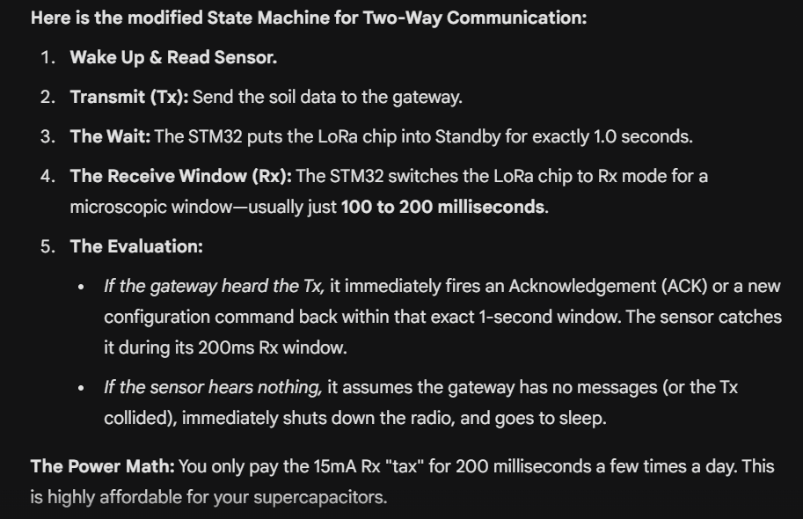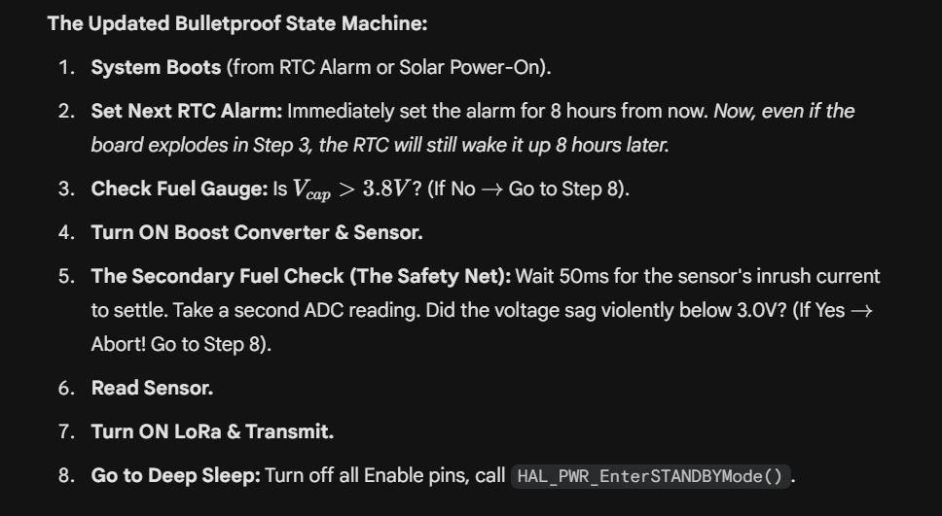
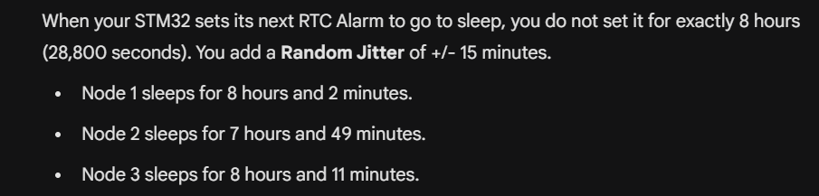
GateWay
- ESP32 is selected since it has inbuilt wifi stack!(Later we can use this for integrate with wifi)
- ESP-idf is the platform we are going to use. I need to learn esp-idf also, so that’s why I chose this.

Instead of storing the scaling factor for every single node, you tie the scaling factor and the data structure to the Sensor Type.

In the ESP32's memory, I need to create a configuration array (the "White-list"). When I pair a new sensor, I just tell the ESP32 its Node ID and its Type.

// Gateway Memory (The Lookup Table)
typedef struct {
bool is_active;
uint8_t sensor_type; // 1 = NPK, 2 = Temp/Humid, 3 = Capacitive
} NodeConfig_t;

NodeConfig_t NodeDatabase[256]; // Array to hold up to 255 nodes

// When I "pair" Node 20 as a Temp/Humidity sensor:
NodeDatabase[20].is_active = true;
NodeDatabase[20].sensor_type = 2;

When a packet hits the ESP32 antenna, the LoRa Rx Task wakes up, reads Byte 0 (Node ID), and looks up the sensor_type in the database.

Then, it uses a switch statement to decode the raw bytes (Bytes 3 to N) differently depending on what the sensor is.

The Final Payload Blueprint
The Header (Standard for EVERY packet - 3 Bytes):
Byte 0: Node ID (e.g., 0x14 for Node 20).
Byte 1: Device Profile ID (The "Decoder Ring").
0x01 = RS485 NPK/Moisture Sensor (Expect 14 bytes of data)

0x02 = I2C Temp/Humidity Sensor (Expect 4 bytes of data)

0x03 = Capacitive Moisture Sensor (Expect 2 bytes of data)
(These are rough plan, we need to finalize this)
Byte 2: Supercapacitor Voltage (e.g., send 38 to represent 3.8V. You must track the node's fuel gauge on the gateway!).
The Data Payload (Variable):
Bytes 3 to N: The actual sensor readings.

